Spelling -Changes and all heads would be in Title case
Career@MITTAL CRAFTWORKS
Best Sellers
Anniversaries
BeSpoke Gifting ( add)
Terms & Conditions
FAQ

Remove

Gift Automation
Submit your rfq
Multi – recipient Sending

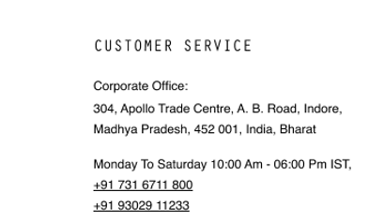

Social media sequence

Insta/fb/x/youtube/linkedin

