Source- https://gravity-drive-service-center.profcymabackend.com/manage-pickup-drop/pickup-drop-images

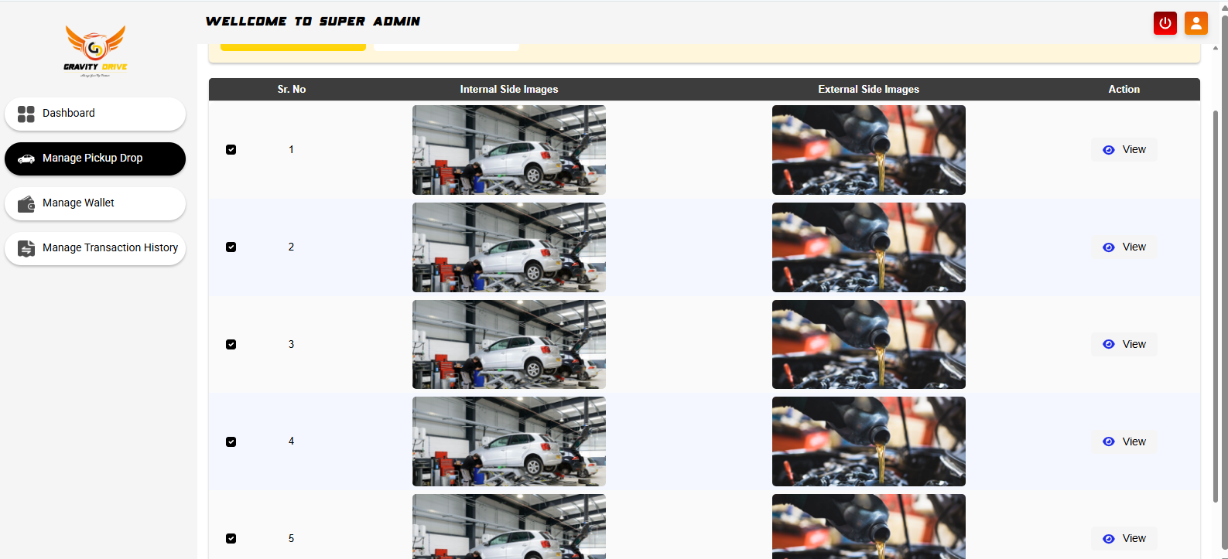Need Download option single or all

Source- https://gravity-drive-service-center.profcymabackend.com/manage-pickup-drop
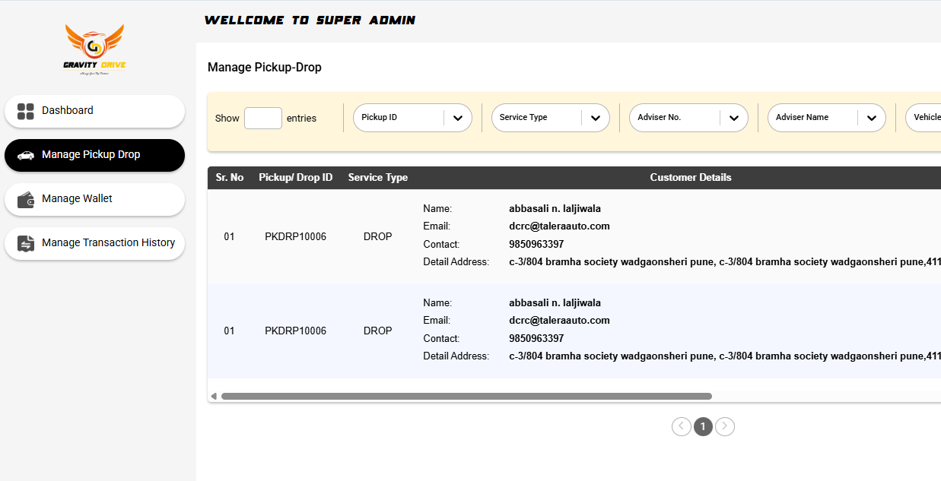
Need PICKUP/DROP Punch time
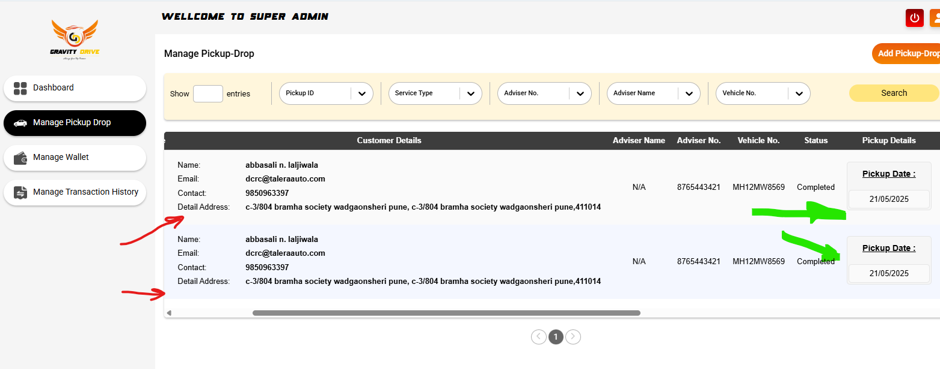
Pickup Time CRM NAME and DROP Time SA(Service Adviser) NAME

Green Mark – Date with TIME Slot need

----------------------------------XOX----------------------------------------------
Source- https://gravity-admin.profcymabackend.com/manage-ambassador/ambassador-edit

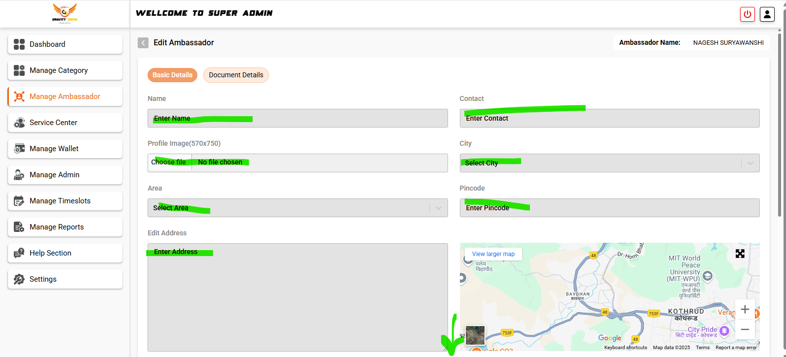
We need this info(Basic details and documents details) automatically fetch from our mobile app on new user registration time

Source- https://gravity-admin.profcymabackend.com/manage-reports
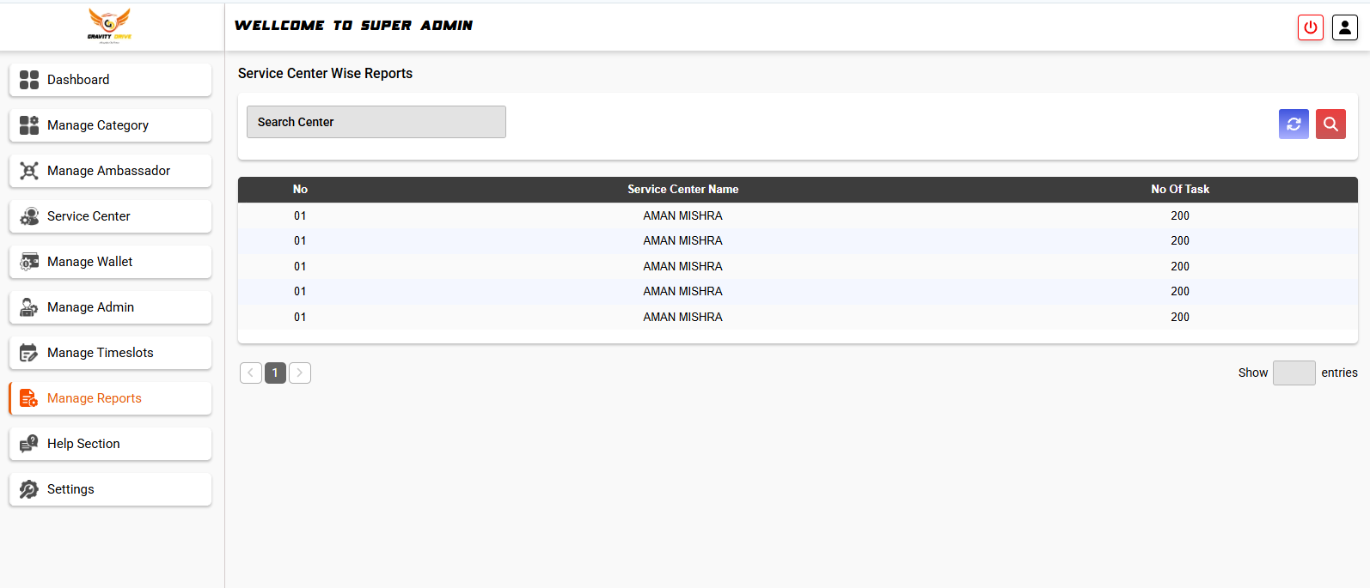
We need this showroom wise reports excel with Graphical dashboard

11-06-2025 Till date
-------------------------------------------------------X0X----------------------------------------------------------------

