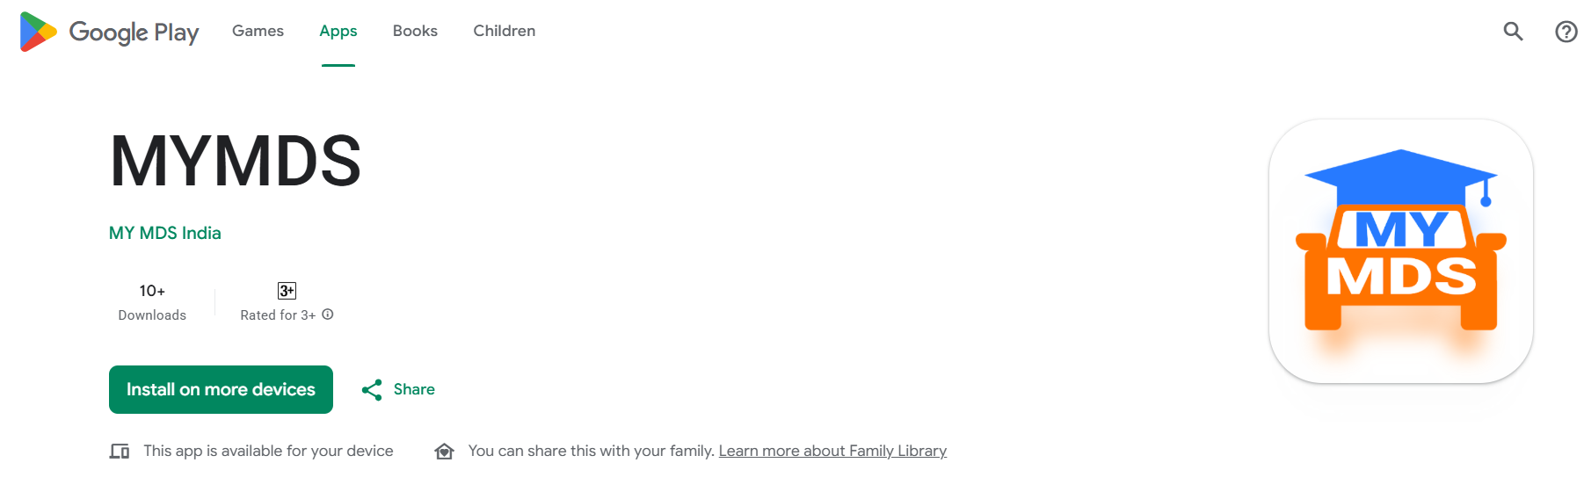
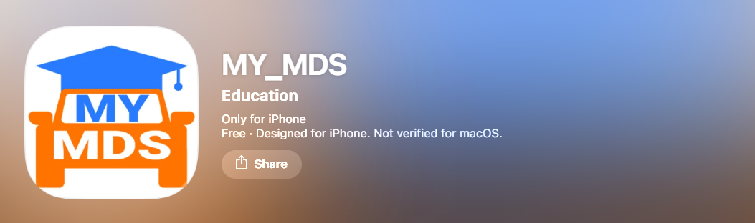
1 App name should be consistent for Google Play store and Apple Appstore Use any of the following
My MDS, My_MDS, MY MDS,
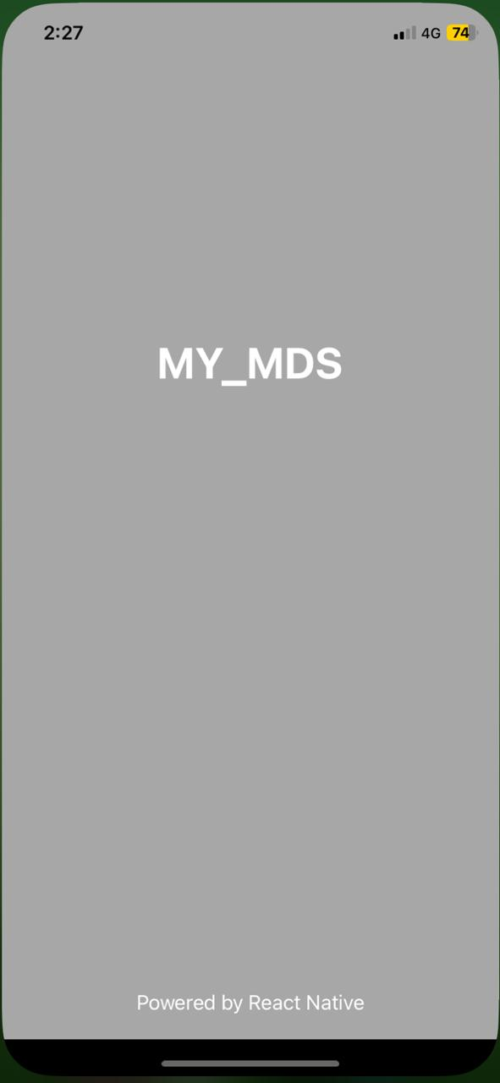
2 Once we click on the app fist app name appears on black screen remove that
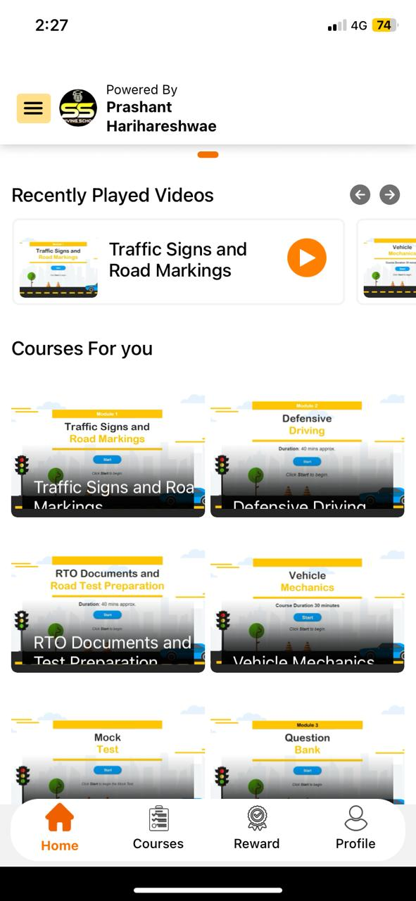
3 Course names are getting cut also there is black gradient box on top which is not covering the entire thumbnail (Gap in both side)
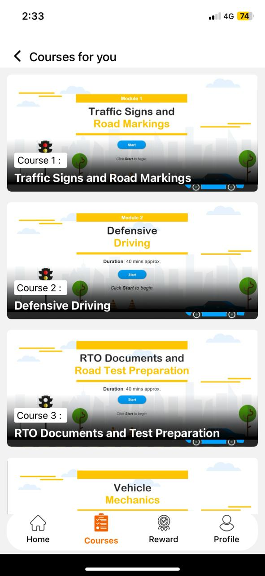
4 Black gradient box on top which is not covering the entire thumbnail
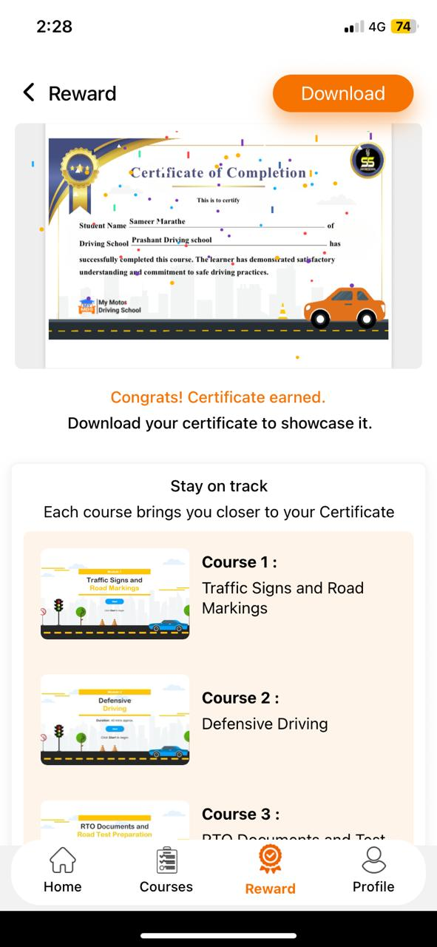
5 Not able to download certificate. App shows file is downloaded but it is not getting downloaded
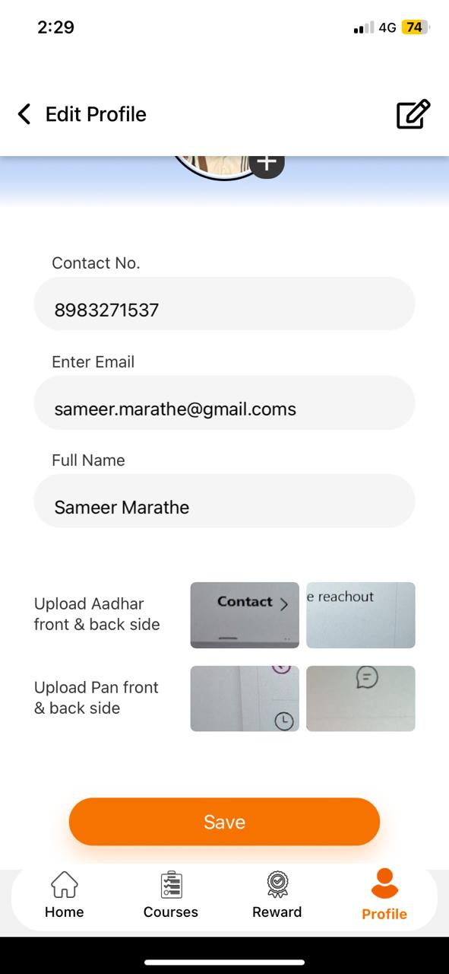
6 When clicked on profile to edit unable to perform anything
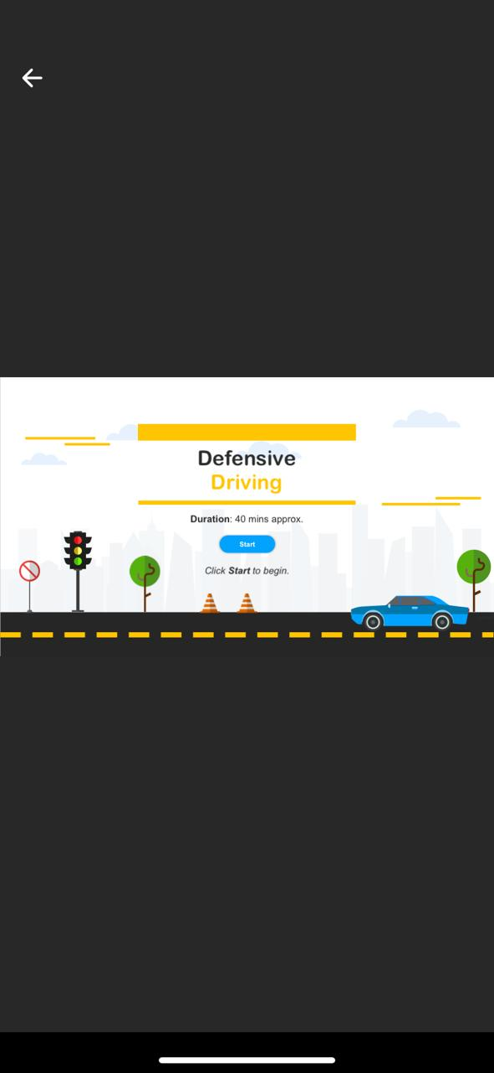
7 When clicked on any course “Vendor logo” is not visible
8 App is not working in landscape view
9 OTP is coming from Profcyma as a text sms and not from My MDS whatapp message

