Google Console
- Name Correction – secureestate (Current)
Required – Secure Estate
- App Link Name Correction- https://play.google.com/store/apps/details?id=com.profcymasolutions.navsiddhi_mobile_apk&pcampaignid=web_share
- Unable to find app on Google ads or meta ads for app promotion

Tablet – UI/ UX Misalignment
- Unable to send OTP (button not working)
- Misalignment unable to use on tab
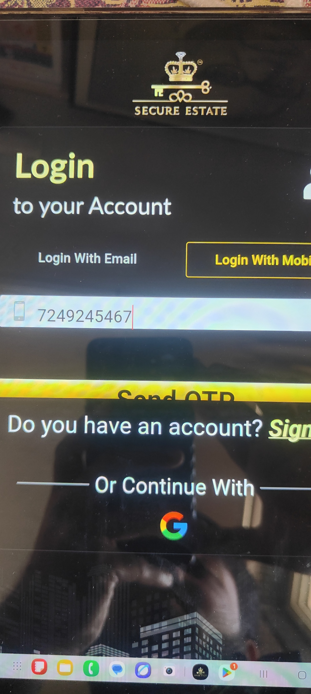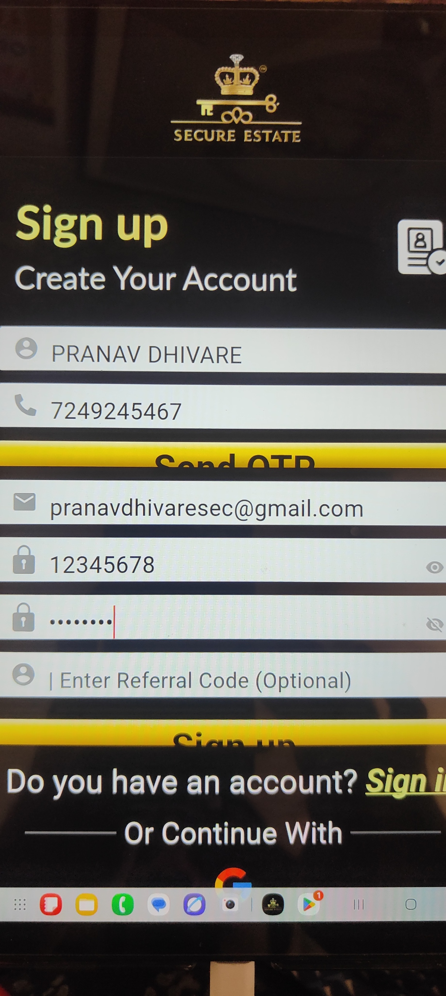

Mobile App
- Loading time is too high (10 -15 sec) Need optimisation
- Issue refer image below
- 1st project name (Montage) is in correct location company name is in correct location kalash properties
- 2nd Project name - Loyal Touch project Name Is correct location but company name is incorrect – its showing person name
- 3rd sometimes its auto replace tower name instead of company name and remove sub locality too.
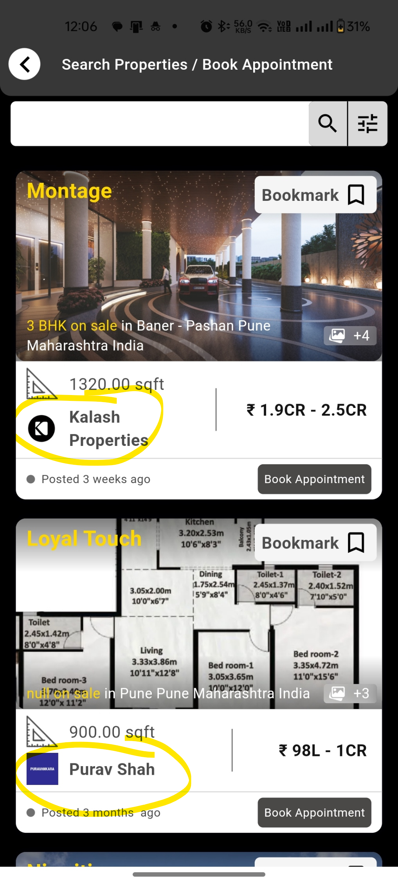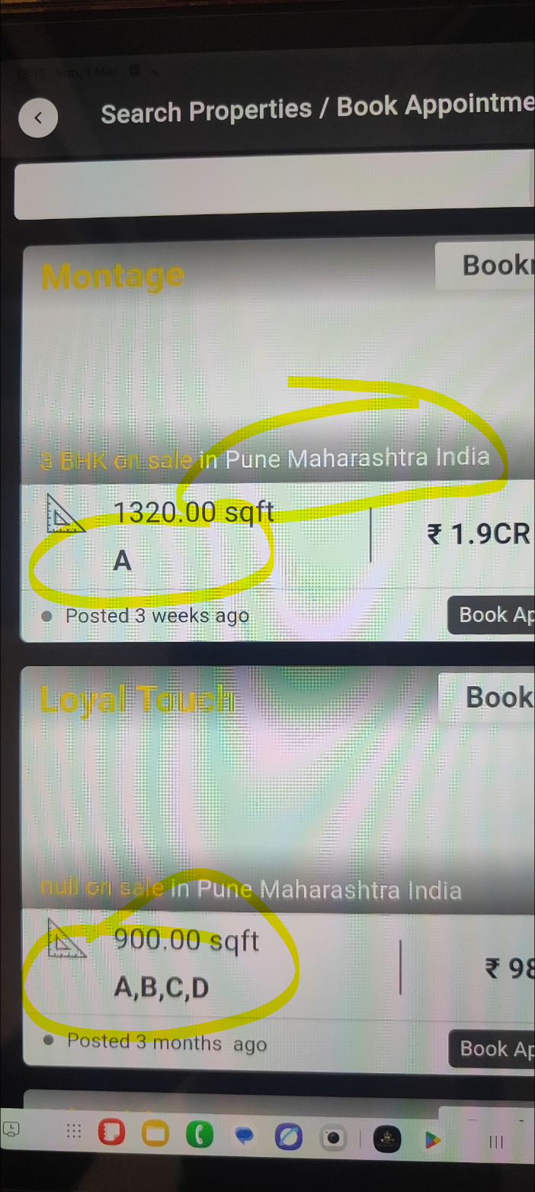
- Appointment booking timing change to slots
Explanation : currently user can choose timing like 1.54 pm etc we require a slot booking like 12 -1 pm , 1- 2 pm, 2-3 pm (only for site visit) for easy booking
- Hidden Coupon – Pending
Explanation: from admin we add new promo code then some Promocode it should not show on app
- Bestprice Discount Coupon – Pending
- Notification Name – its should be the user name
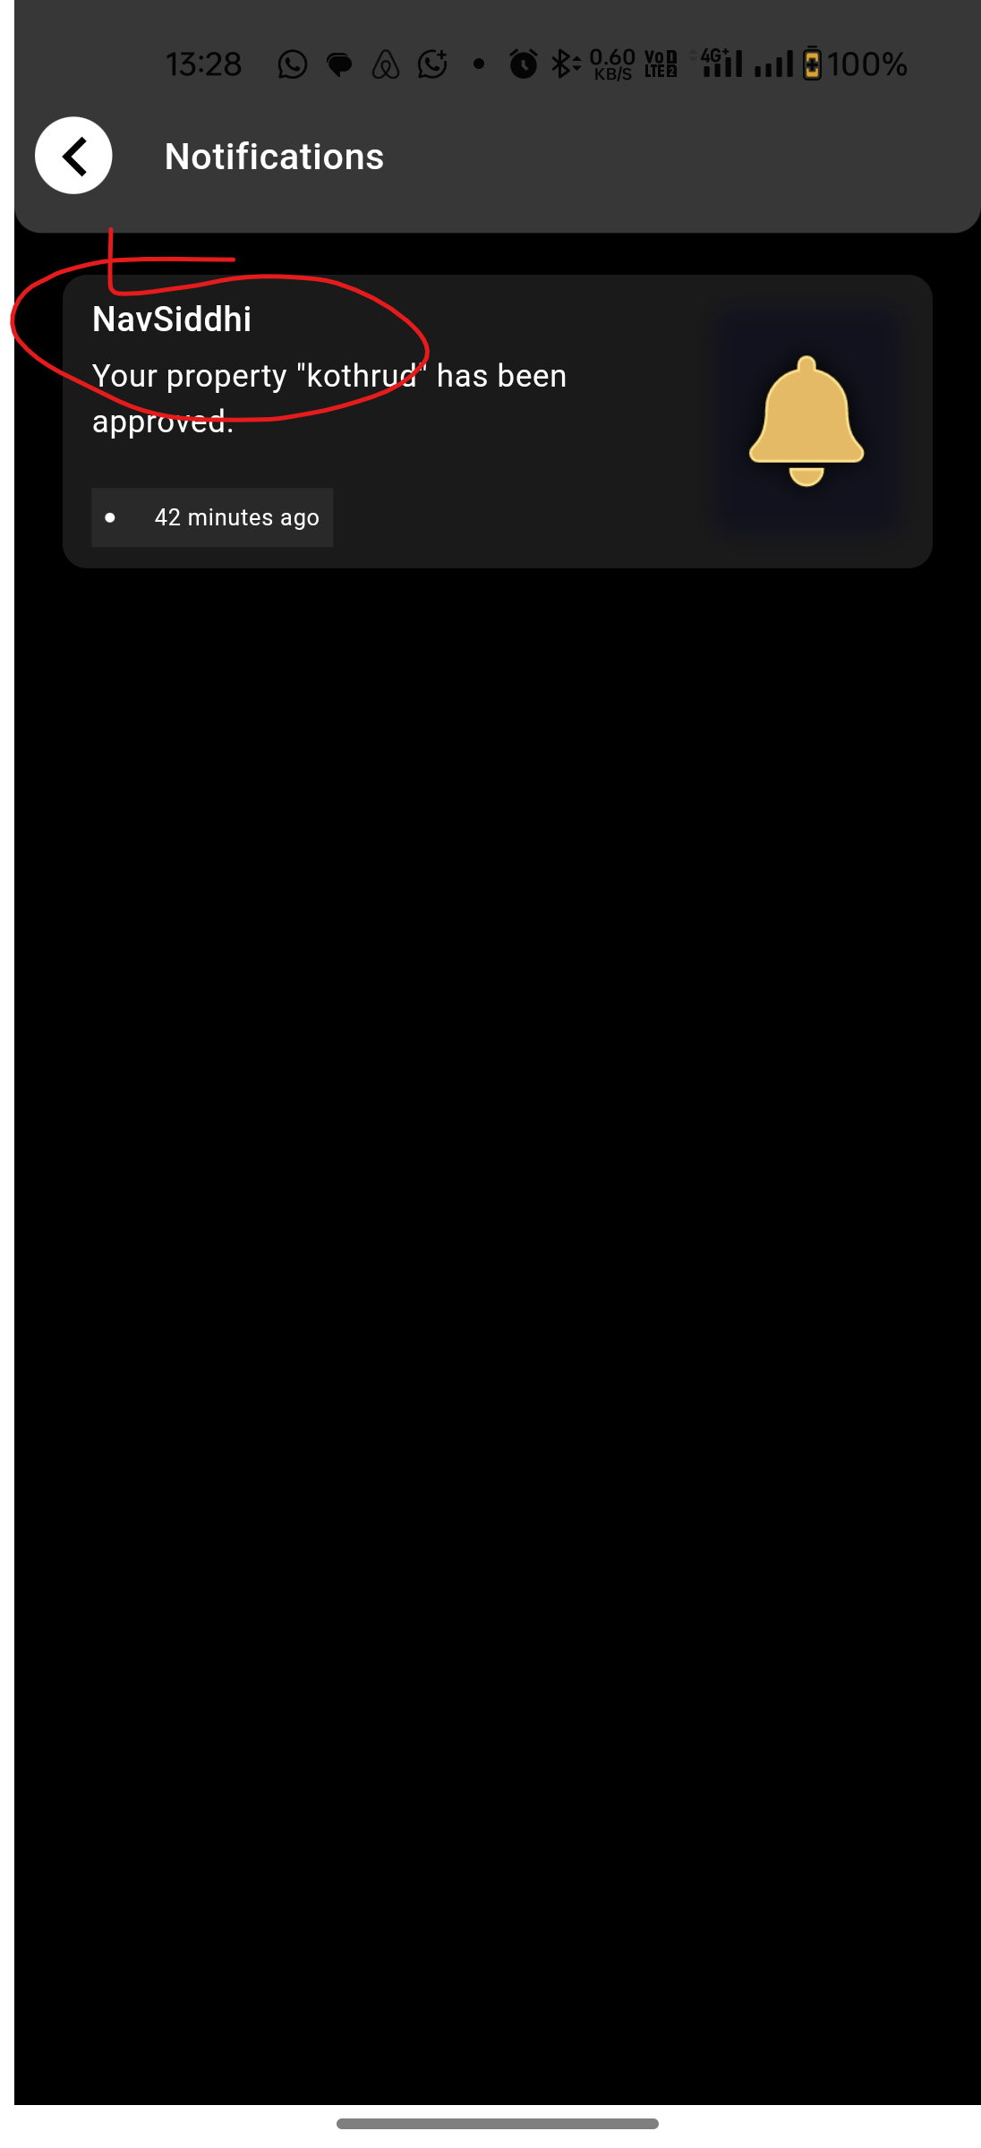
- Highlight button –
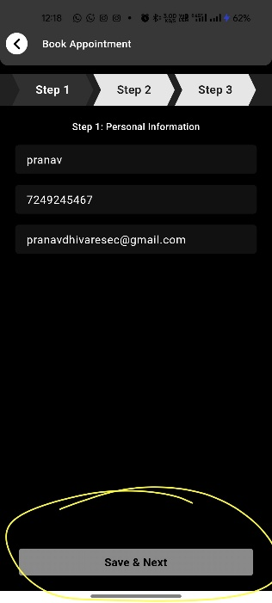

- Need to remove the Gray box only button should be visible for all drop down like add property section etc.
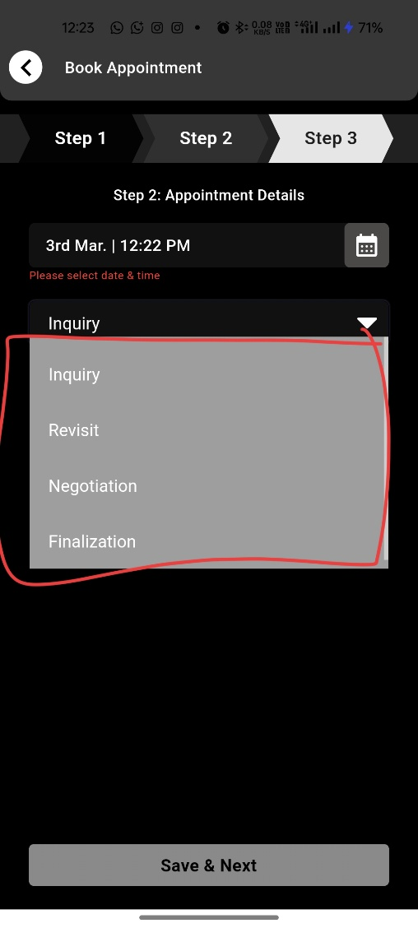
- Rename - in add property (document upload section )section
1 | Sale Deed
2 | Possession letter
3 | Home Loan A/c Statement + Bank NOC (if any)
4 | Property Tax Receipt
5 | Share certificate
6 | NOC From Society
7 | Completion Certificate
8 | Car parking allotment letter
9 | Possession letter
10 | Conveyance deed

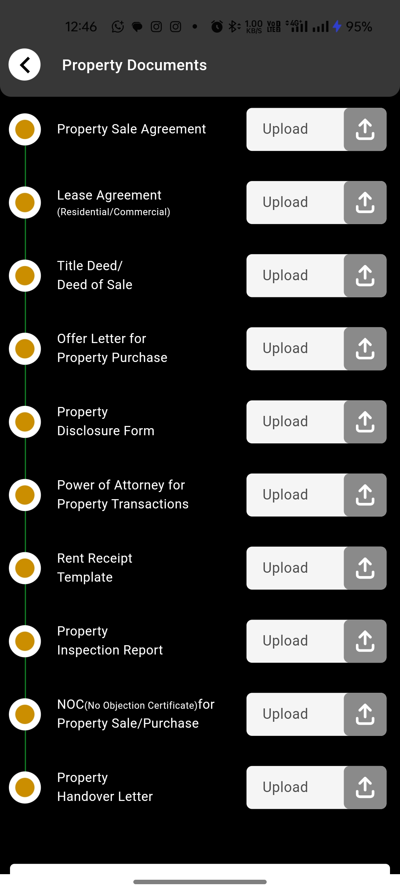
- Auto approval for add property - changes
Explanation – if a user fill details of Add properties then directly they should be option to upload documents without admin approval.
- Rename – Book appointment to Book Site Visit ( Headline, Project – Tiles section and inside project details)
- While Adding property in Property Verification section form – In Entre price Section Needed (Comma (,) E.g One Cr (1,00,000,00)

Admin
- Complex to list project – change
Please Refer video - https://drive.google.com/file/d/1Gzy-zk2QXVJRBMm96_eEXOLyBYYKJuDE/view?usp=sharing
- Pending Task Button like notification
Explanation – to identify the enquiry and pending approval
- Loader of Each Task
Explaination – to avoid multiple clicks
- Error Mention – to identify the actual error
- Name Change of tab to Secure Estate

- builder and project should be link if builder Is removed then project also need to be removed
Explaination – if we remove builder then automatically there project also need to be removed. Currently if we removed the builder there project is still visible.
- Push Notification Not Working

- Risk Assessment report download – incomplete
Refer - https://drive.google.com/file/d/15xXlk71Ayn3XvfknoB7vxbfdLs3hD5pp/view?usp=sharing
- Invoice issue i) Logo ii) Misalignment
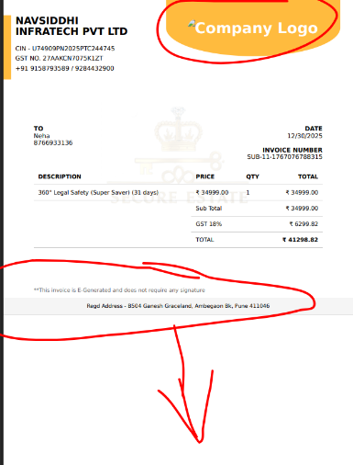

- Loan Enquiry Not Working
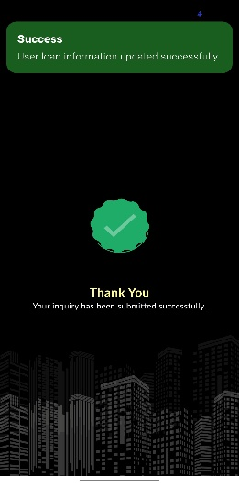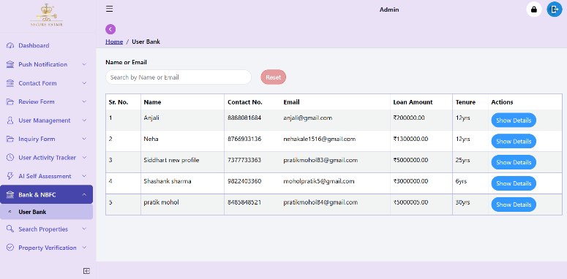
- Company Name should be visible in offer and coupon section
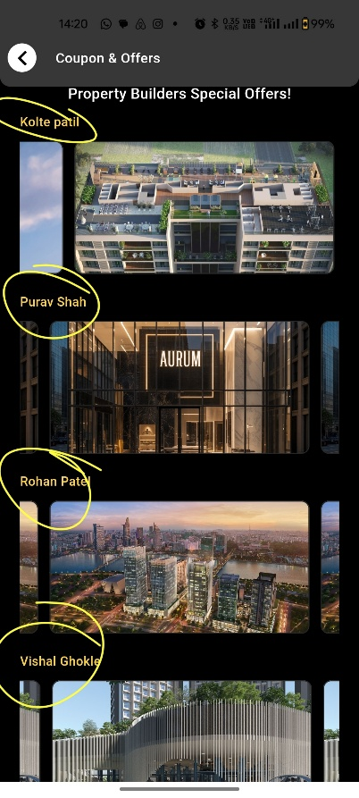

- Banner Aspect ratio size details for each section – to avoid image cutting
- Ai Self Assesment) Step 2 of appointment booking > in Purpose of Consultation – Remove of text MCQ Consultation, Legal advice before buying, etc
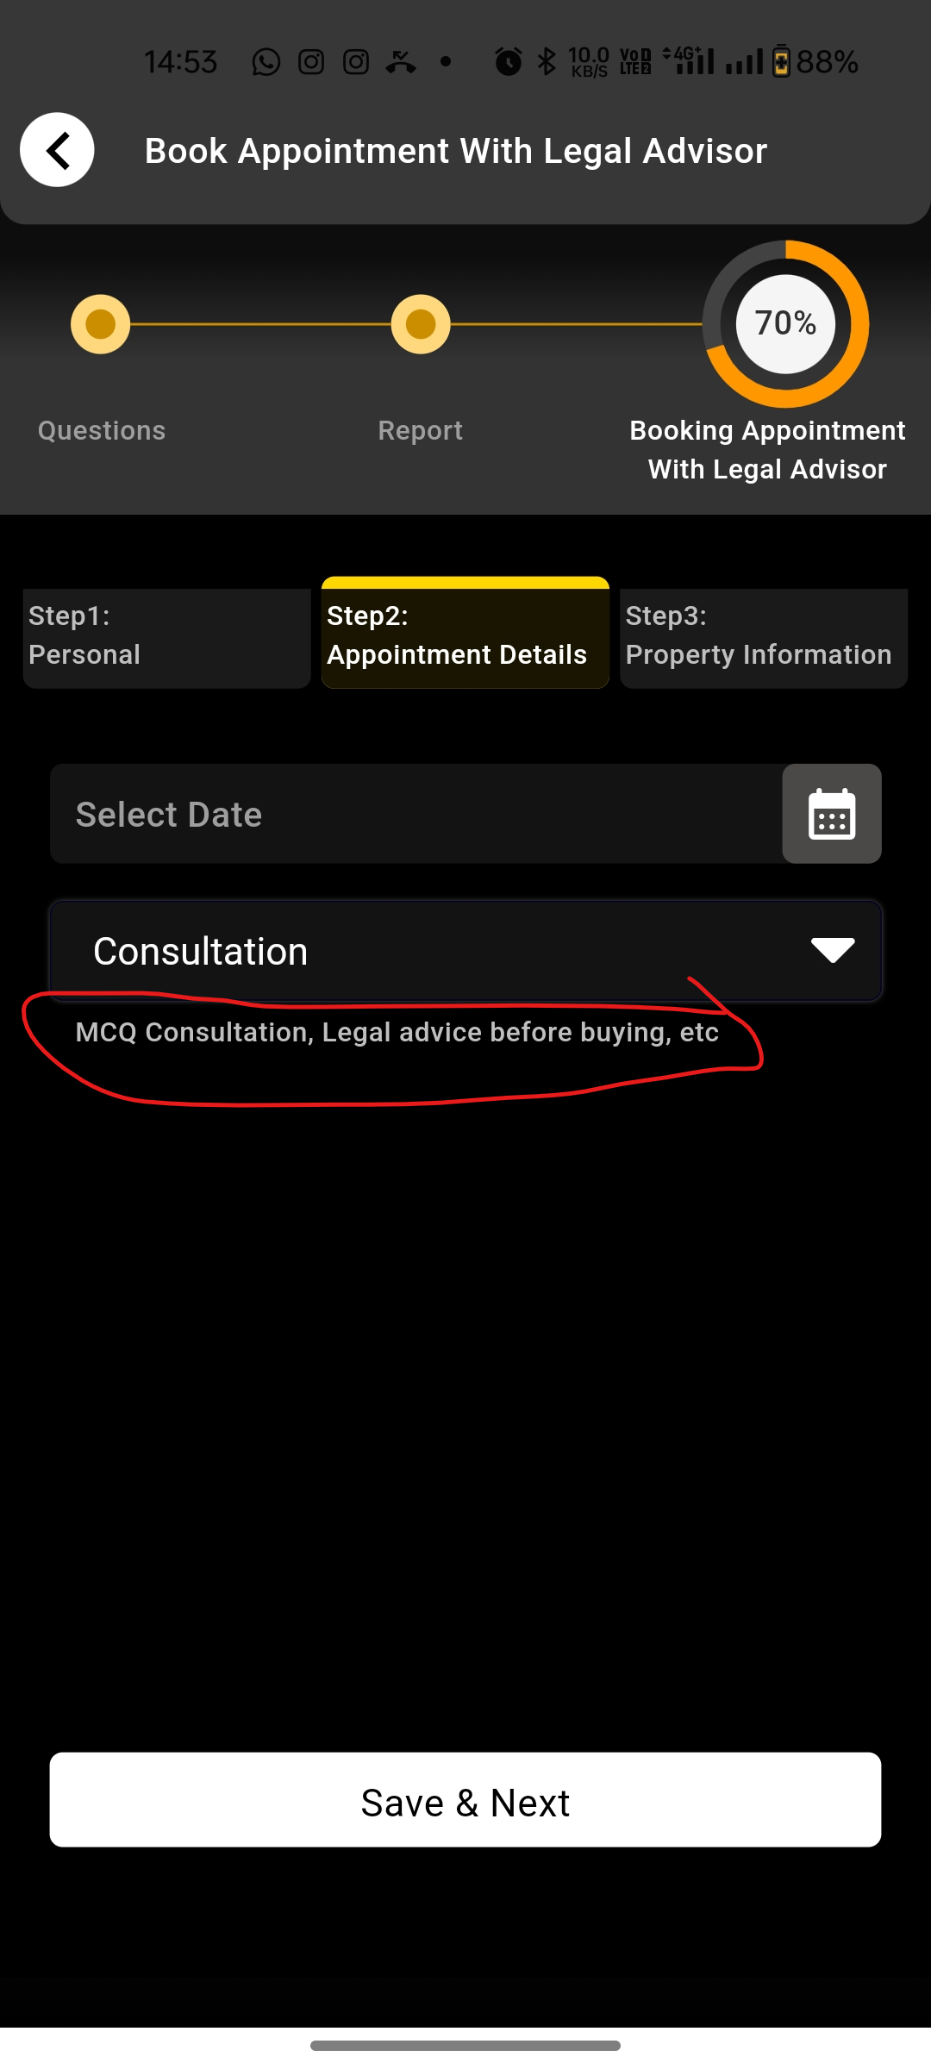

- (Risk Assessment) Step 3: In Additional Preferences replace to Additional Details, replace (if any special Request) to – (Please add any more Information)
Website
- If we Enter www.secureestate.in - Page does not load (This site can’t be reached)
If we Enter Secureestate.in website is Working
- Images is Not Changed – Pending
- OTP Account Need to Change – Currently working on profcyma solutions

