Recent Feedback 06/04/26
Admin
- Name Correction – Spelling mistake
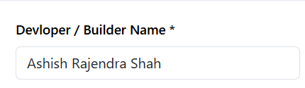

- In Media Section – Name Correction - Click to Upload Video
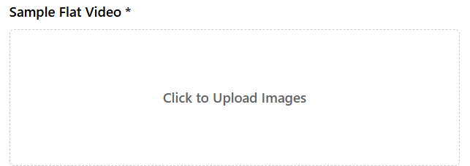
- Media file should be both Image and PDF
Explanation – both file it should be able to upload
- Spelling Mistake – of Brochure
- Multiple Images can be uploaded like project image, layout plan,
- Loader Pending
- Clickable icon
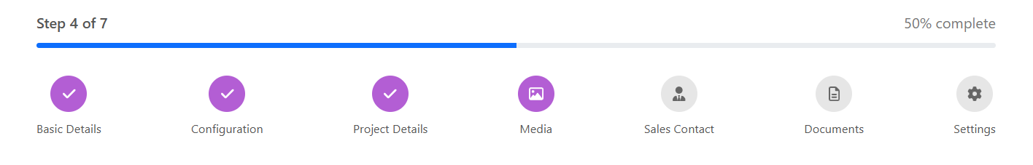
- Push Notification Not Working - pending
- Loan Enquiry Not Working (unable to check)
- Risk Assessment report download – incomplete (unable to check)
- Invoice issue i) Logo ii) Misalignment (unable to check)
- Company Name should be visible in offer and coupon section (how to add the offer – unable to find)
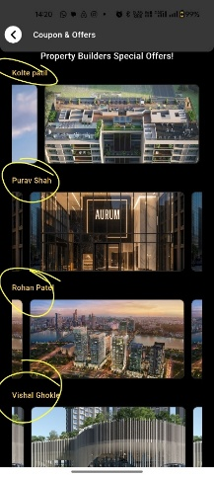

Application
- Image is cutting – amenities
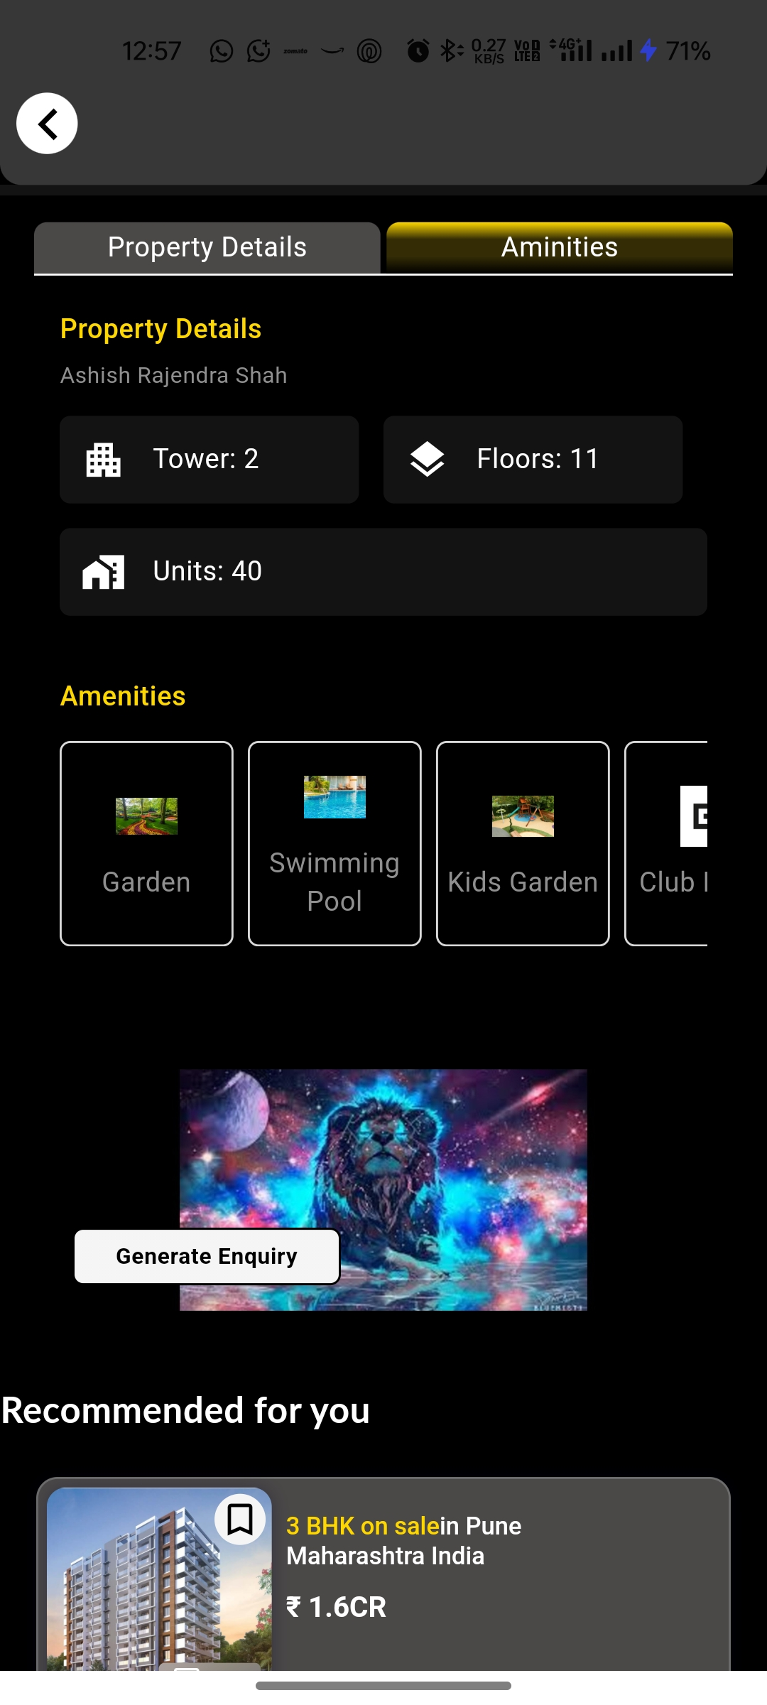
- Tablet Alignment Pending –
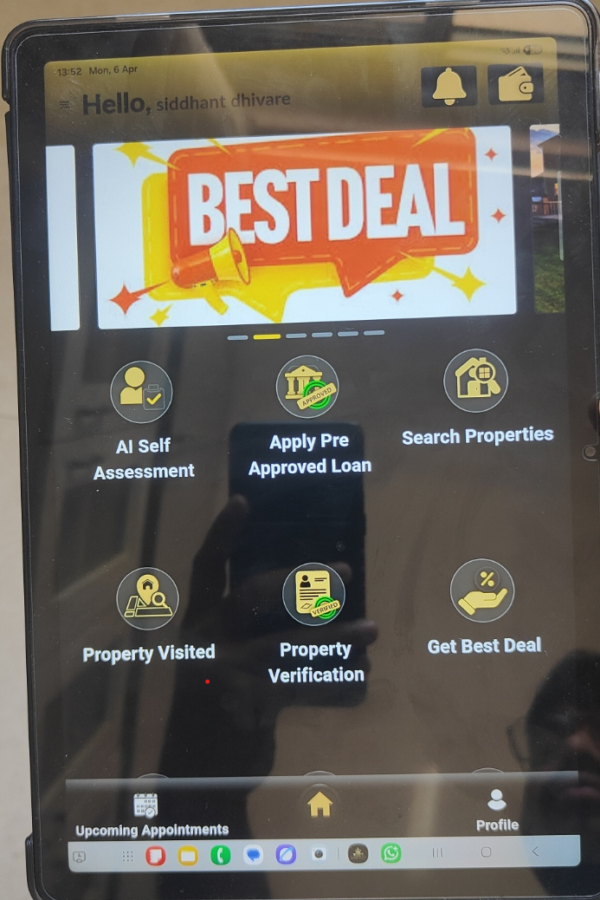

- Organization Logo need to add
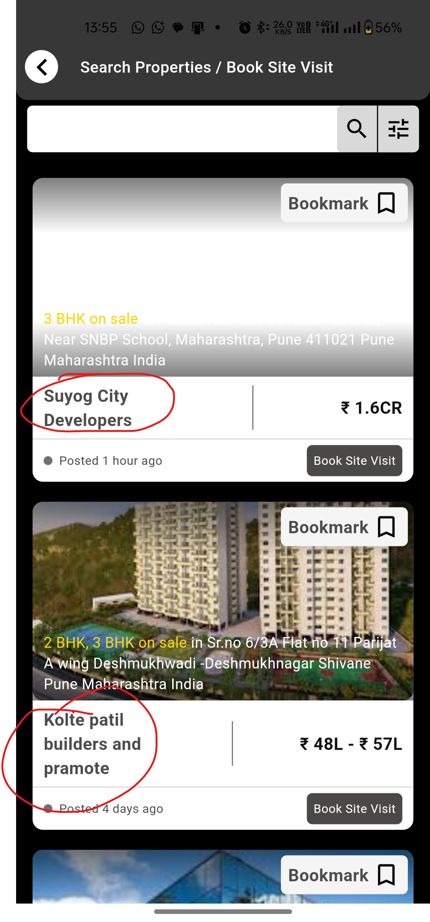
- Unable to add property (error)
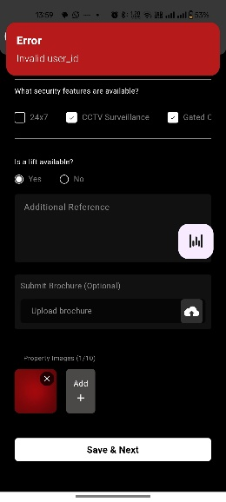
- Notification Name – its should be the user name – Pending
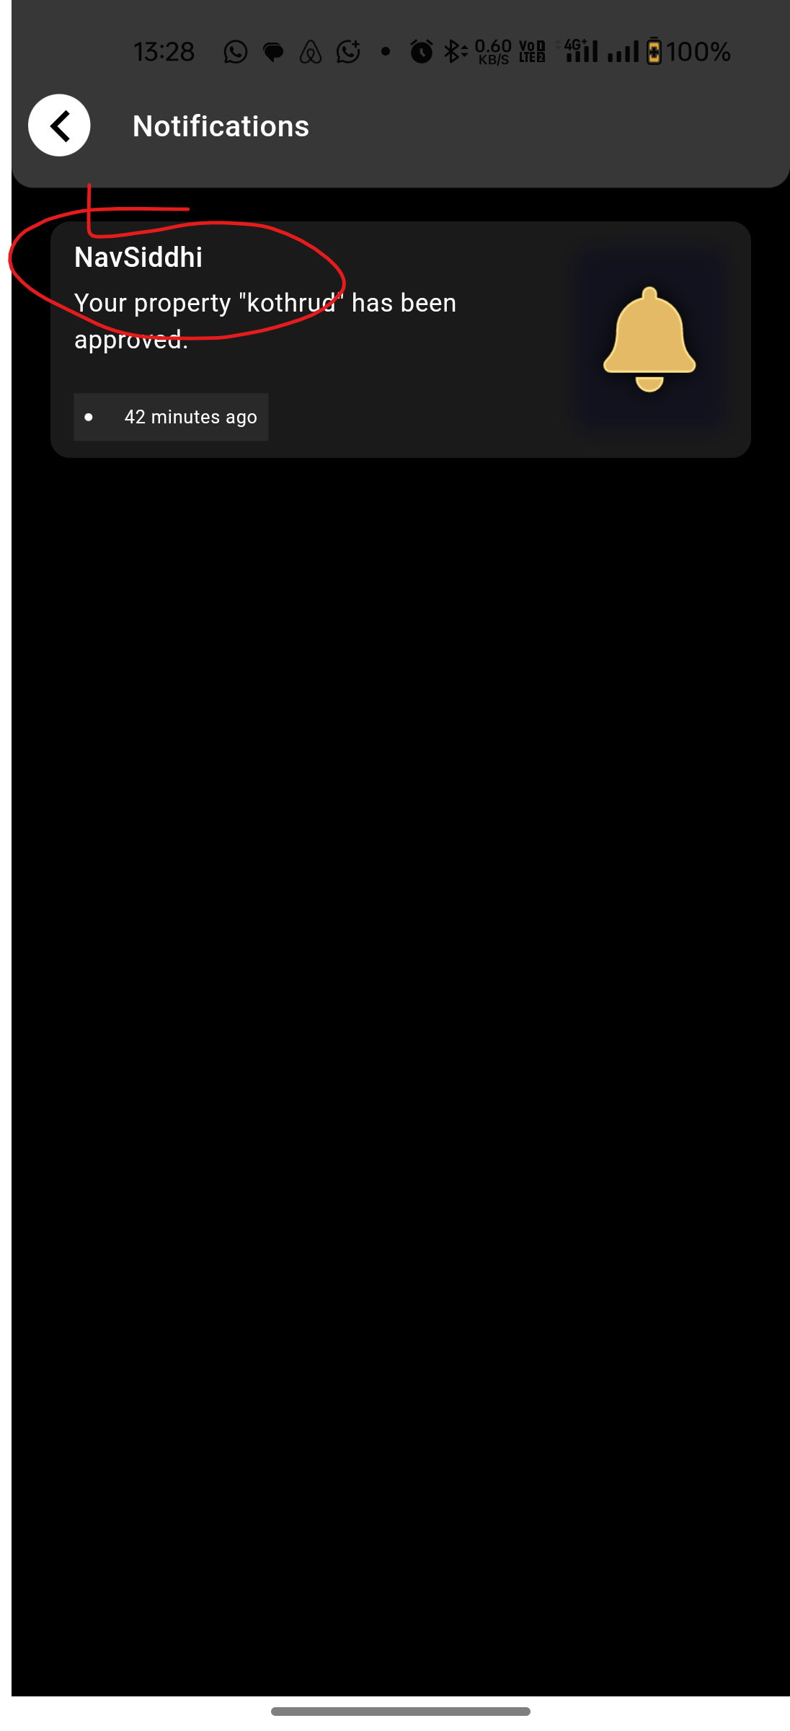
- Highlight button - pending
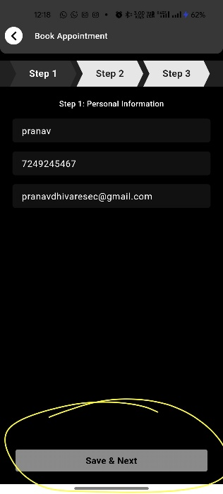
- Rename - in add property (document upload section )section
1 | Sale Deed
2 | Possession letter
3 | Home Loan A/c Statement + Bank NOC (if any)
4 | Property Tax Receipt
5 | Share certificate
6 | NOC From Society
7 | Completion Certificate
8 | Car parking allotment letter
9 | Possession letter
10 | Conveyance deed

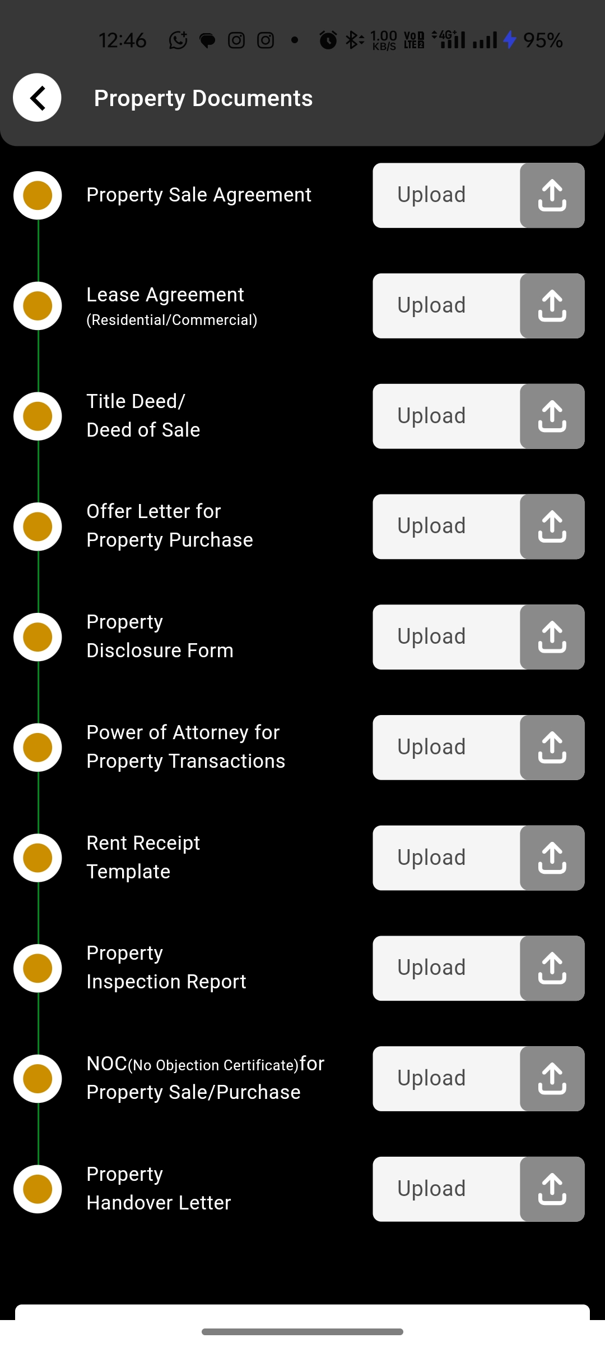
- Auto approval for add property – Unable to add property
Explanation – if a user fill details of Add properties then directly they should be option to upload documents without admin approval.
- Download Brochure content – shall now be visible on media of the project
Explanation – its only for download the brochure
- Bestprice Discount Coupon – (project is not visible after bookmarked)

Google Console (Pending)
- Name Correction – secureestate (Current)
Required – Secure Estate
- App Link Name Correction- https://play.google.com/store/apps/details?id=com.profcymasolutions.navsiddhi_mobile_apk&pcampaignid=web_share
- Unable to find app on Google ads or meta ads for app promotion

