Website FeedBack
- Builder Signup Form – easy to fill (remove scrolling)
- Text Addition of Logo - (Optional)
- (Playstore icon)Link redirect to Secure Estate App
- Removal of (Real People. Real Properties. Real Reviews.) section with face images
- Text change as per Icon Name 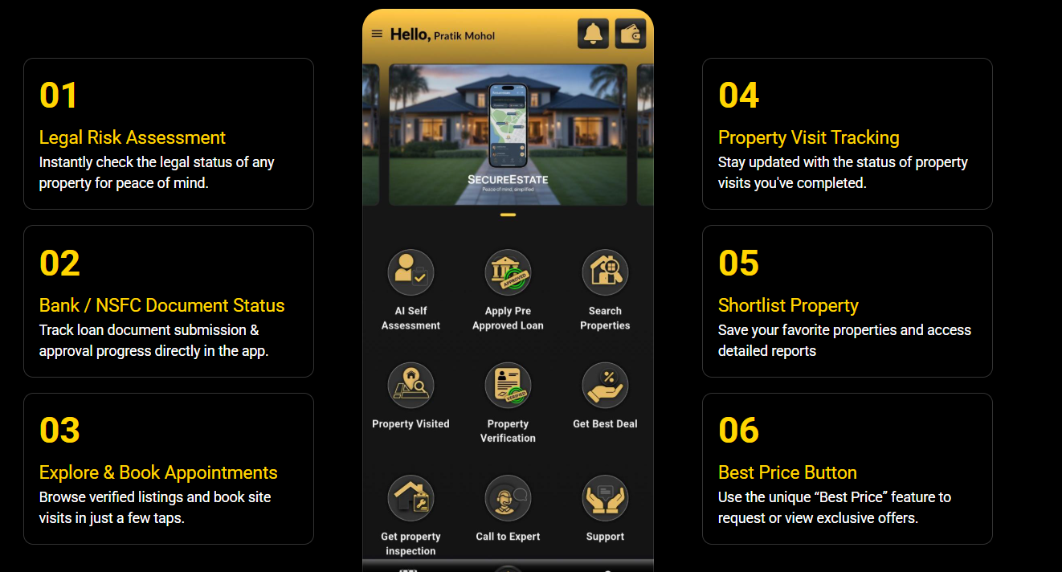
- Name Change of tab to Secure Estate

- Content correction
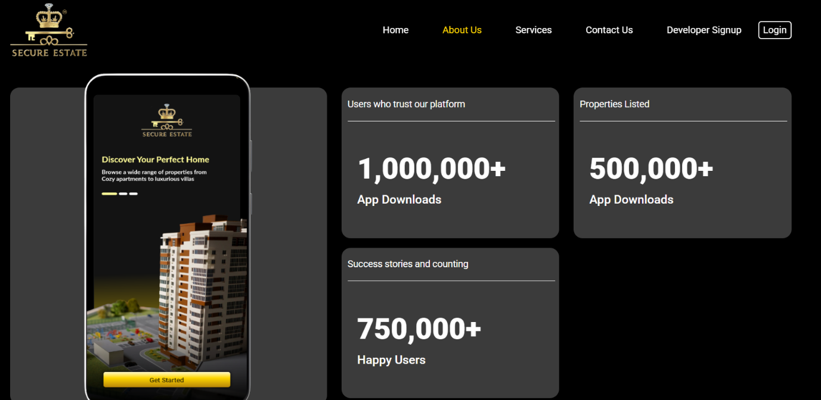
- Pixel integration for App – Mail Send - on 1) oshin.kawale@profcyma.com 2) guddu.kumar@profcyma.com
- Pixel Integration for Website – mail Send 1) oshin.kawale@profcyma.com 2) guddu.kumar@profcyma.com
- 4 Banner images shared

